2022-2023


SOFTMET Software Metrics - Tools and Methodology
assignment1
Student number:2117046
Tool used for this assignment :
Radon – (is a Python tool that computes various metrics from the source code.)
Pylint – (a static code analuser for python2 or 3)
Loc Metrics- ( a software tool to measure a variety of LoC metrics.)

first Report – python code
Here are the screenshots of the code before improvements:
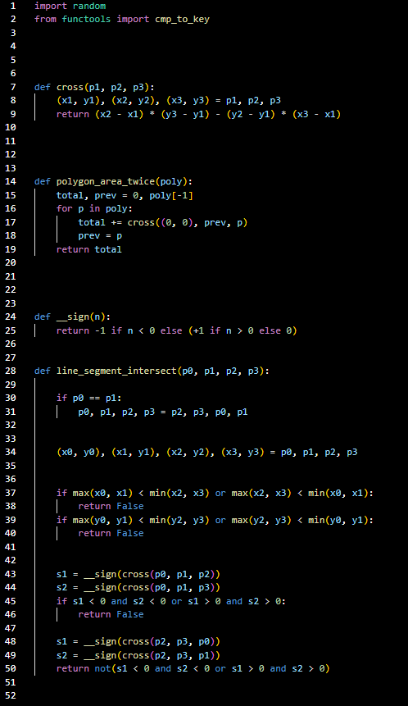
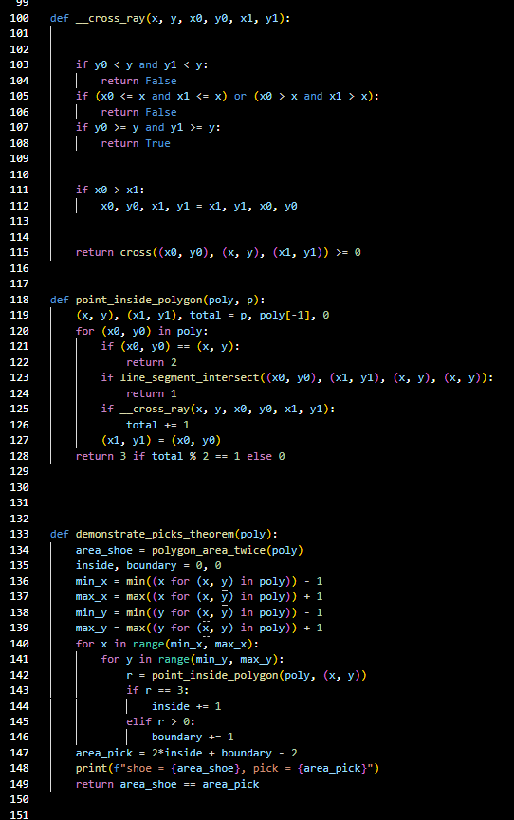
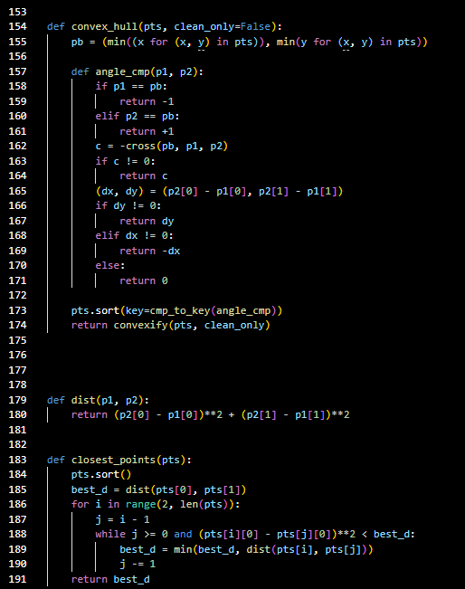

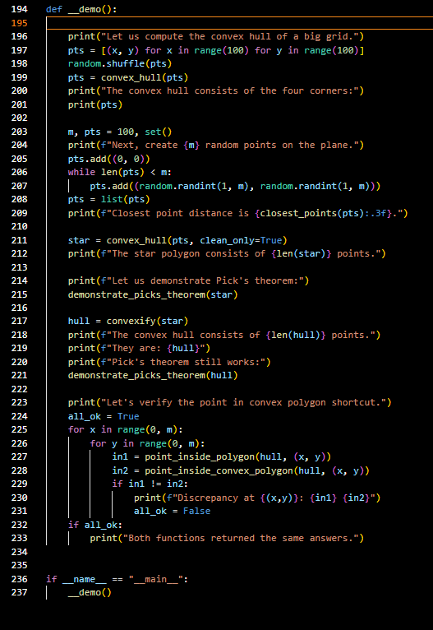

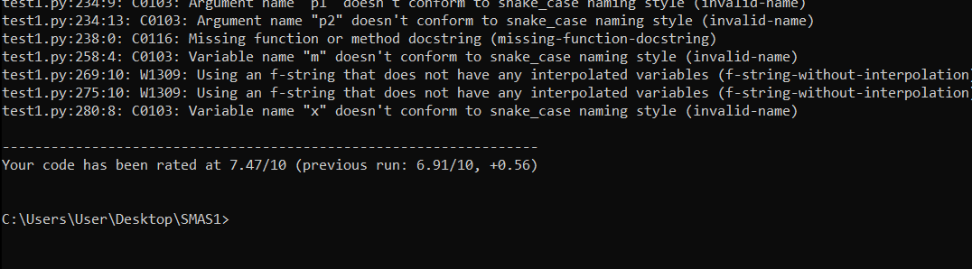
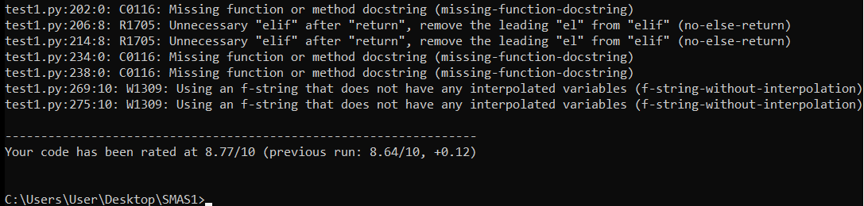
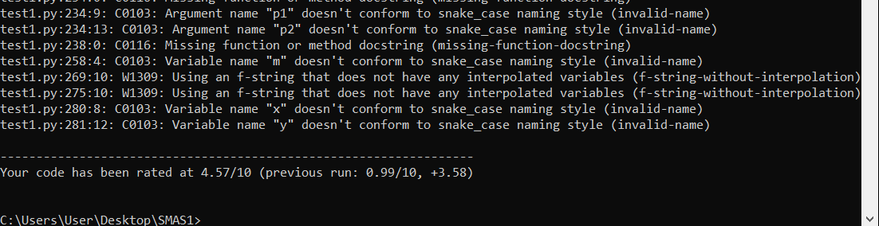
Here are the result calculated with radon and pylint:

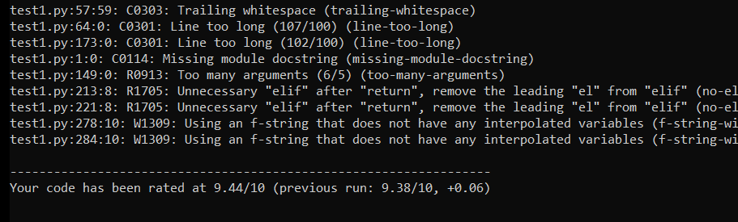
Here are the Radon results after code improvement.
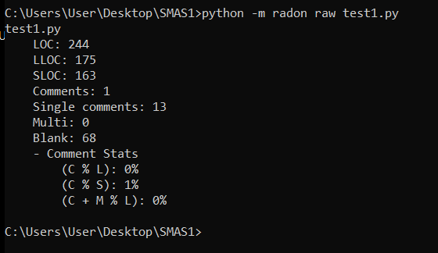
Here r screenshots of the code after improvement:

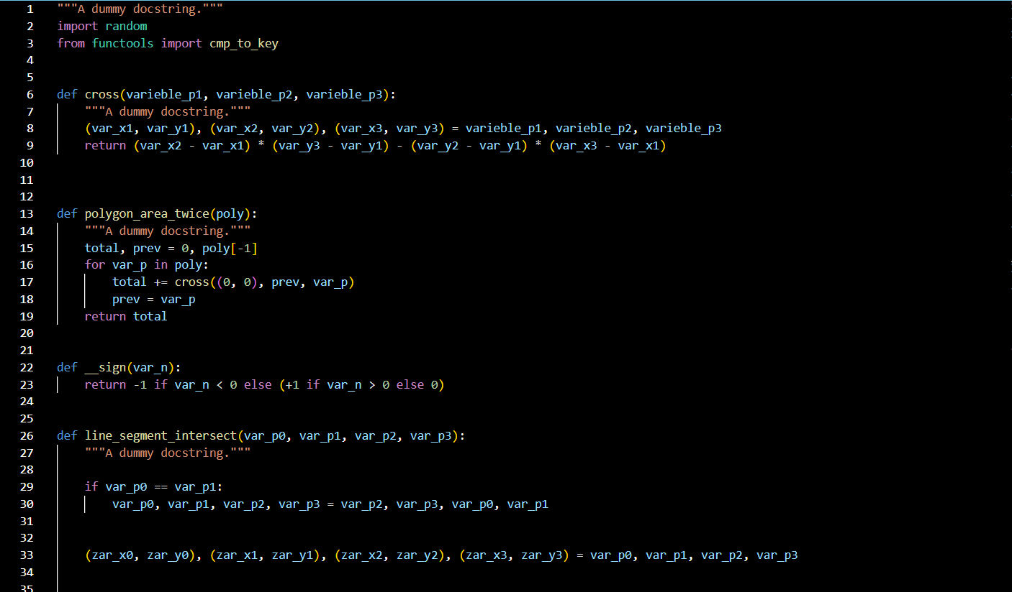

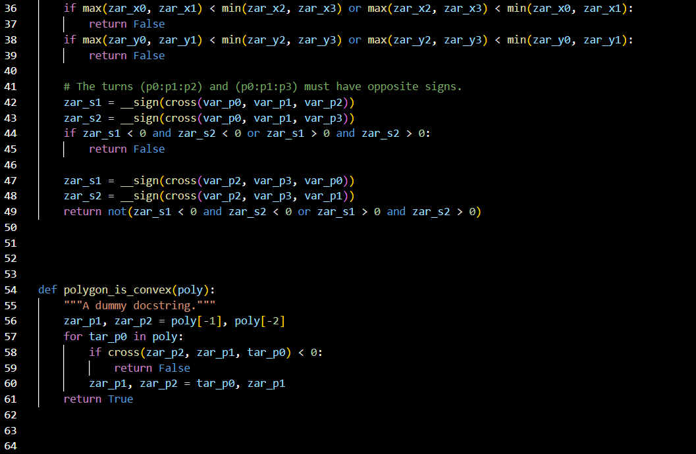
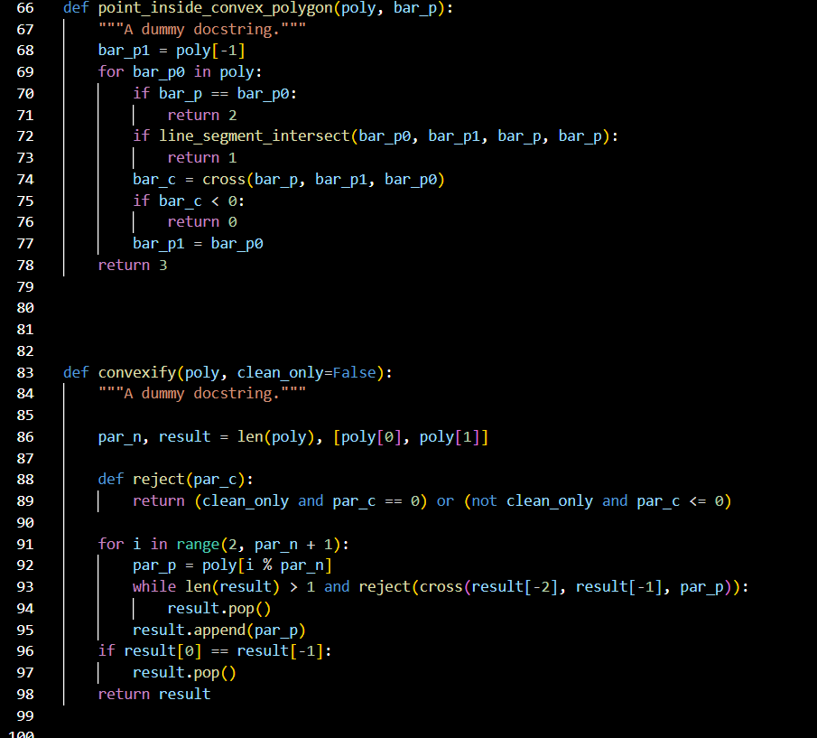
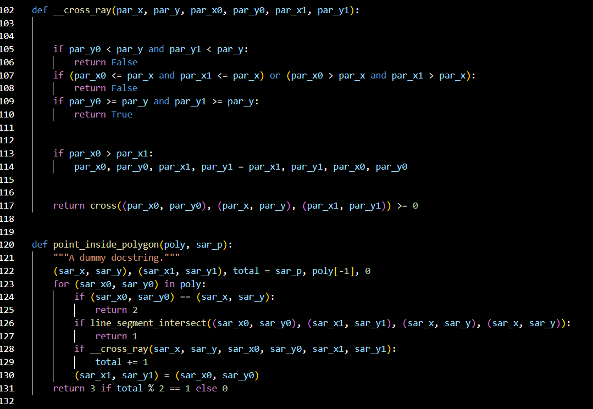
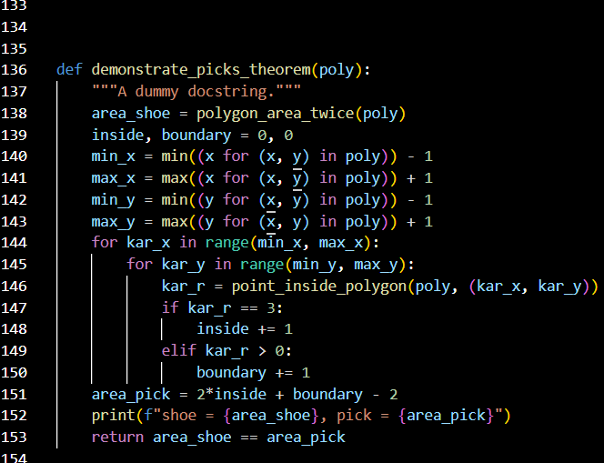
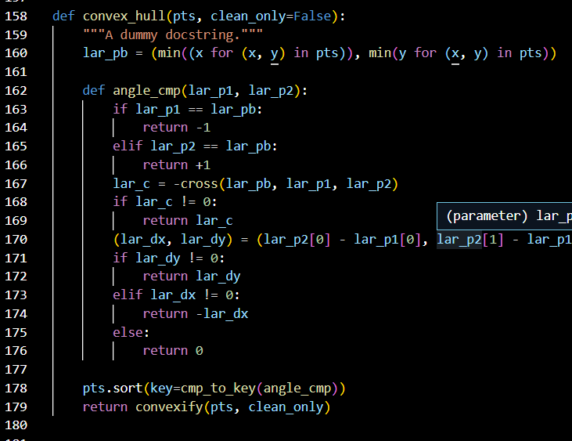
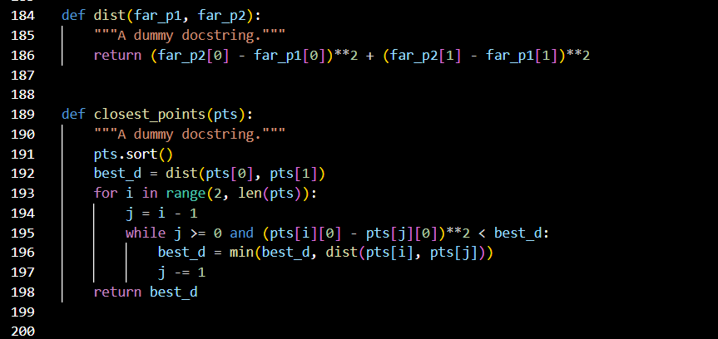
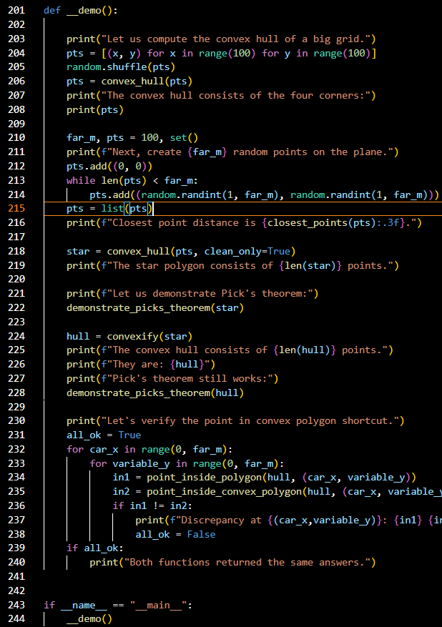
Second report – Java “hello world” code:
Tools :LocMetrics
